Assignment (N+) Wireless Networking
Task-1:
802.11n (Wi-Fi 4): Operates on both 2.4 GHz and 5 GHz bands with a maximum theoretical speed of 600 Mbps.
802.11ac (Wi-Fi 5): Operates exclusively on the 5 GHz band to reduce interference, providing higher maximum speeds of up to 3.5 Gbps.
802.11ax (Wi-Fi 6): Operates on both 2.4 GHz and 5 GHz bands while utilizing better encoding to deliver the highest maximum speed of 9.6 Gbps.

Task-2:
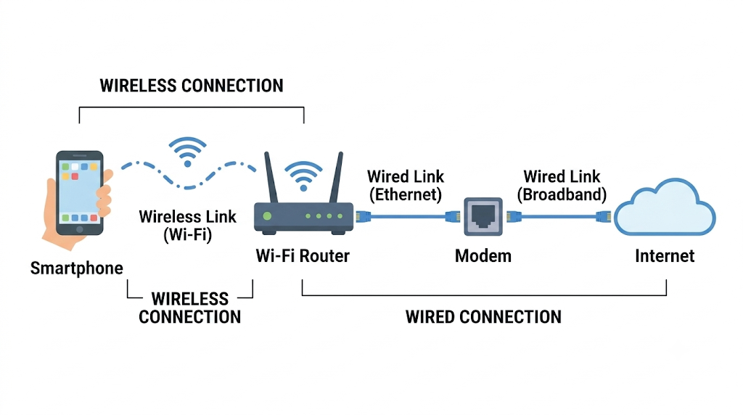
Task-3:
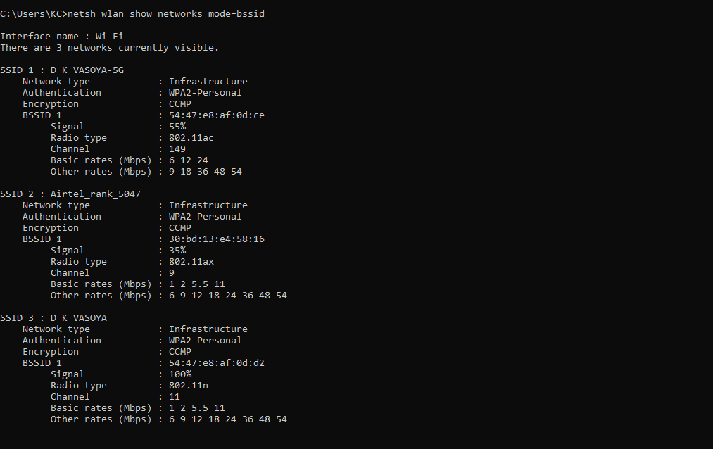
I would choose the "D K VASOYA" network (SSID 3).
Here is the reasoning based on your scan:
- Equal Security: All three available networks use WPA2-Personal authentication, meaning there is no security trade-off between them; they are all safe to use.
- Superior Signal: "D K VASOYA" has a perfect 100% signal strength, ensuring a highly stable and reliable connection.
- Weaker Alternatives: "D K VASOYA-5G" (SSID 1) only has a 55% signal, and "Airtel_rank_5047" (SSID 2) is very weak at 35%, which could lead to packet loss or dropped connections.
While the 5G network (802.11ac) might offer a higher maximum speed threshold, the 100% signal on the standard "D K VASOYA" network makes it the best practical choice for a consistent experience.

Task-4:
SSID hiding is a router configuration where a Wi-Fi network stops broadcasting its public name (Service Set Identifier) to nearby devices. Instead of the network automatically appearing in a phone or laptop's available Wi-Fi list, users must manually type the exact network name and security credentials to establish a connection.
Advantage It provides a basic layer of privacy by keeping the network invisible to casual users, neighbors, or random passersby who are simply scanning for a quick connection. This obscurity prevents the network from drawing unwanted attention from everyday devices.
Disadvantage It creates a false sense of security while making the onboarding process tedious for legitimate users. Because the router still transmits the SSID in plain text within probe requests and responses when authorized devices connect, anyone using basic network-sniffing tools can easily capture the hidden name. It offers no genuine defense against intentional targeted access.

